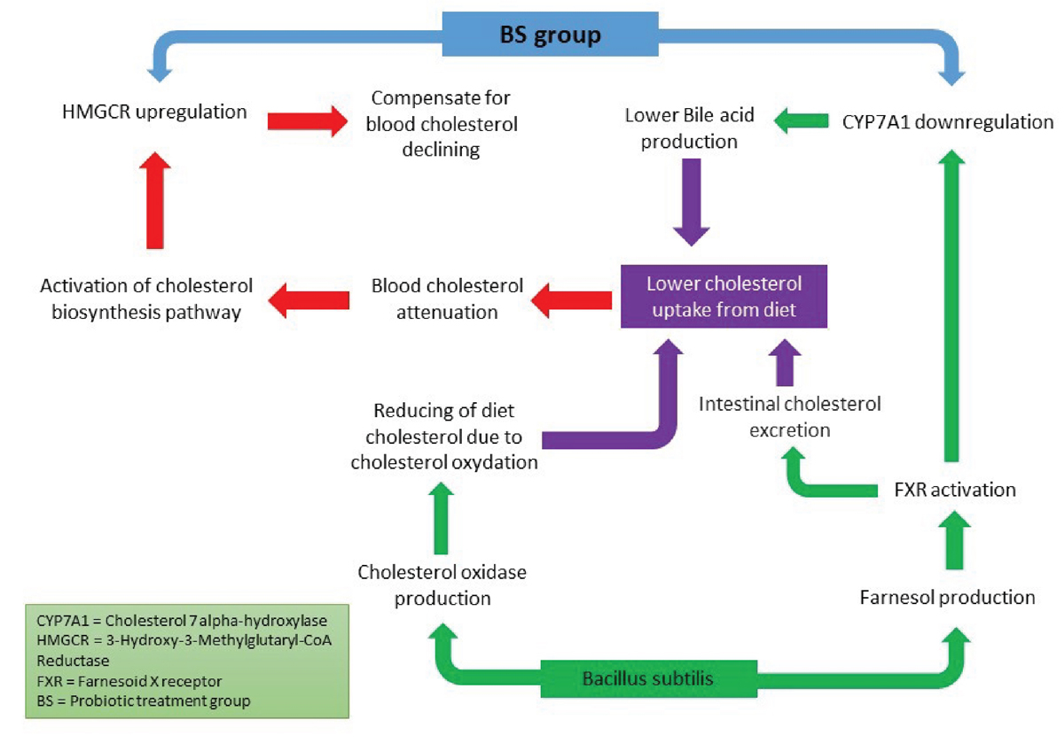

Supplementary Figure 1. Proposed hypotheses of HMGCR and CYP7A1 genes regulation in the BS group. Bacillus subtilis might decrease serum cholesterol levels by two parallel mechanisms. Cholesterol oxidase produced by B. subtilis might metabolize a portion of dietary cholesterol in the gastrointestinal tract. Moreover, B. subtilis can produce farnesol, which leads to FXR activation. This would lead to a decrease in bile acid, and some portion of dietary cholesterol would excrete. FXR activation also causes downregulation of CYP7A1, which subsequently would lead to lower bile acid production and lower cholesterol uptake in the intestine. Decreasing cholesterol uptake might lead to activation of the biochemical pathway of cholesterol biosynthesis and might cause the upregulation of HMGCR.

