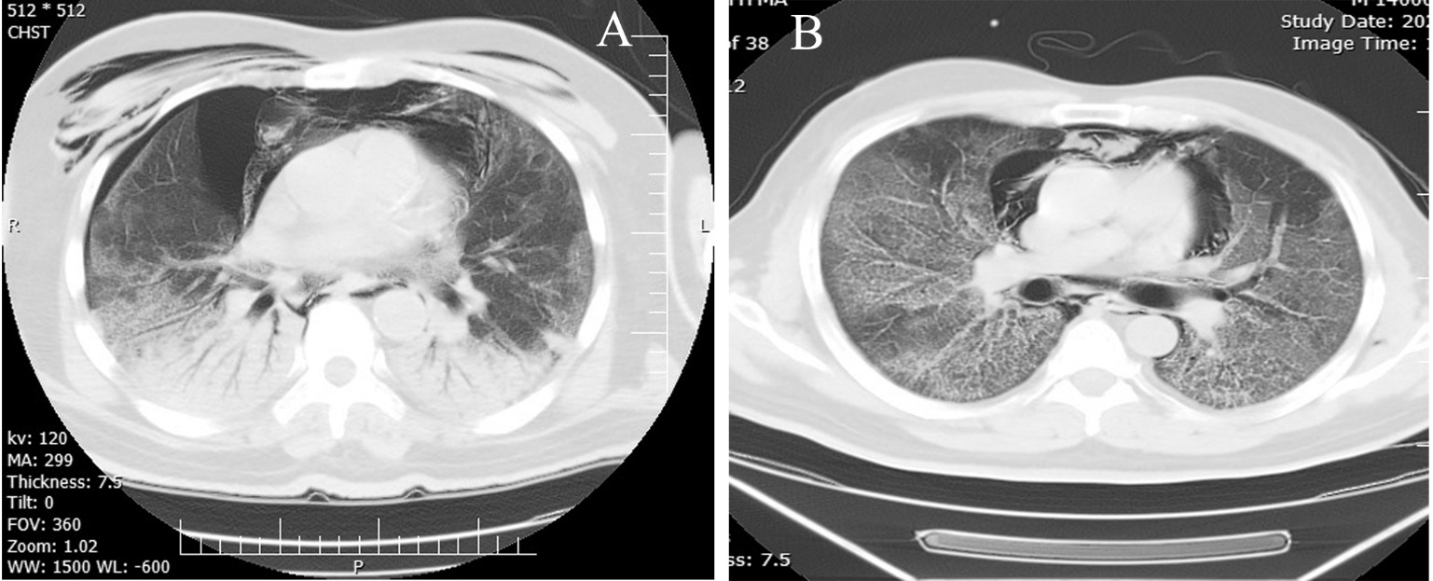

Figure 1. CT scan show pneumothorax and pneumomediastinum and pneumopericardium

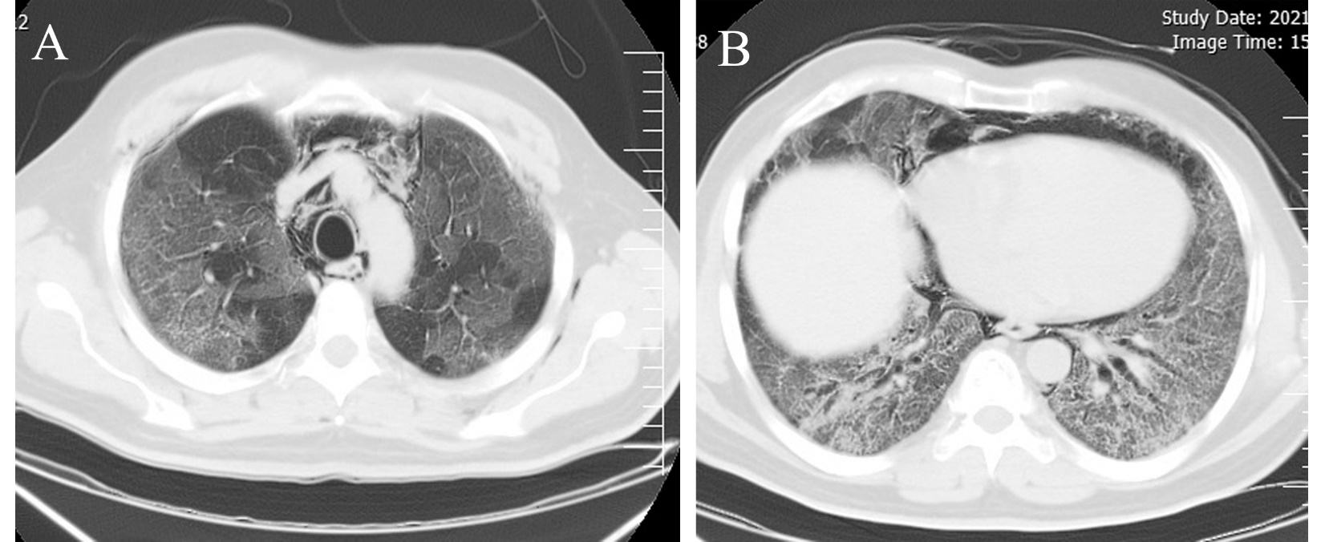

Figure 2. CT scan show pneumomediastinum and pneumopericardium

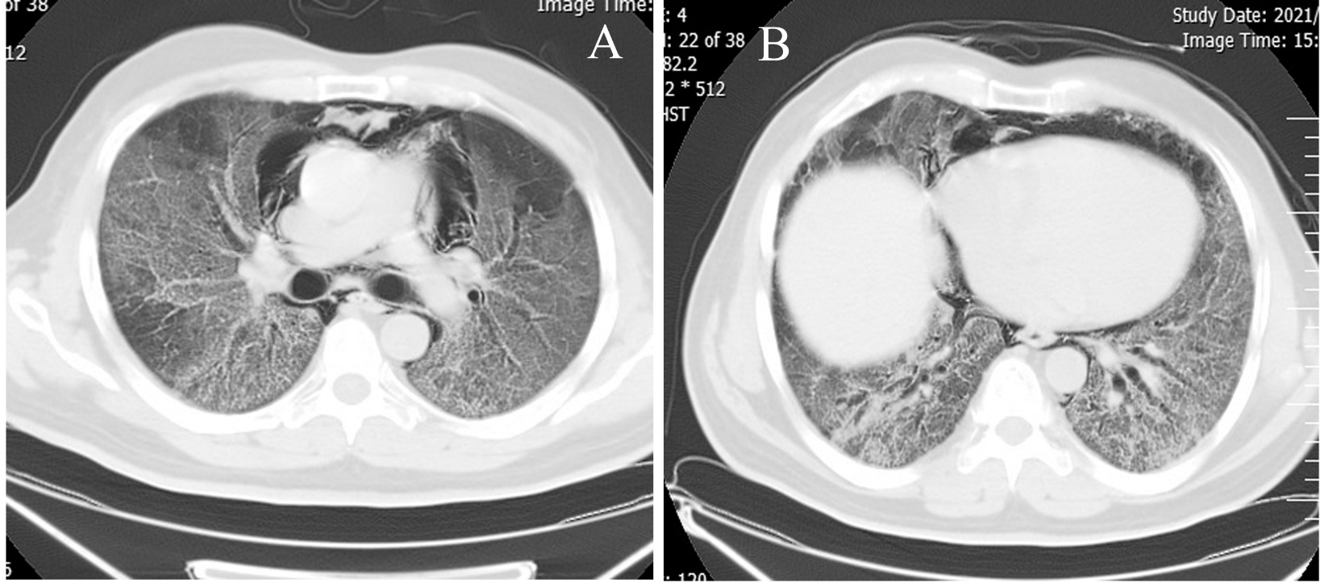

Figure 3. CT scan show pneumomediastinum and pneumopericardium

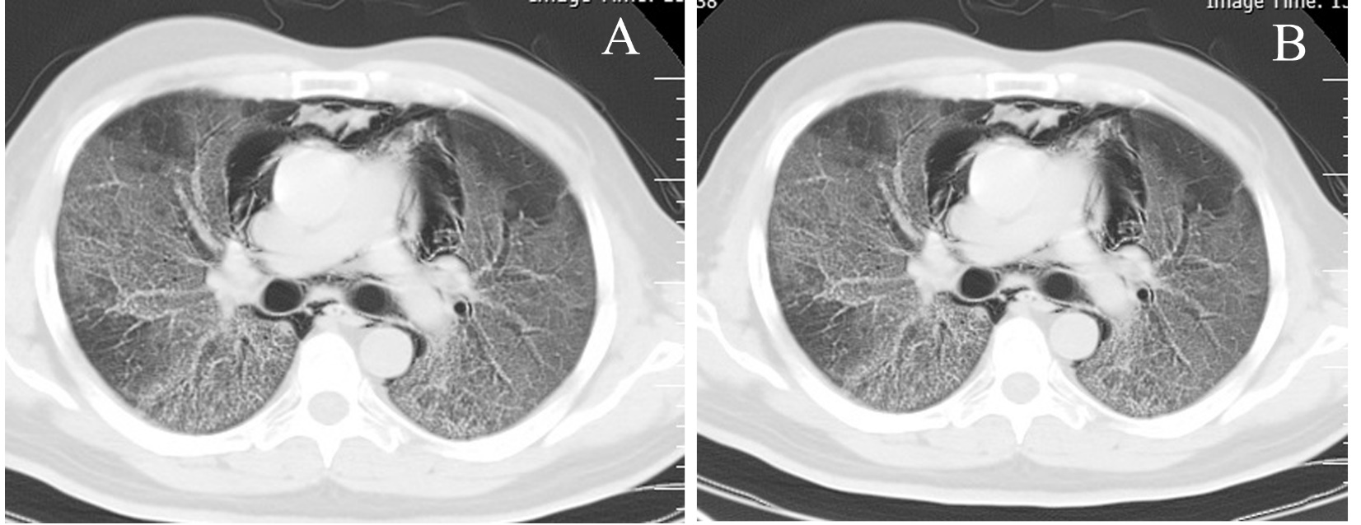

Figure 4. CT scan show pneumomediastinum and subcutaneous emphysema

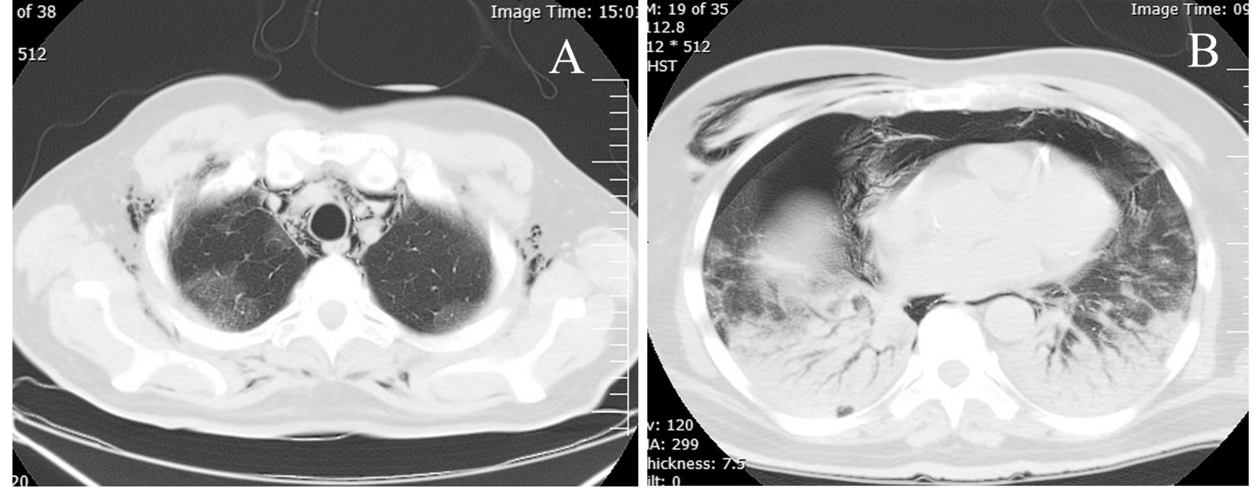

Figure 5. CT scan show pneumomediastinum and subcutaneous emphysema, pneumothorax

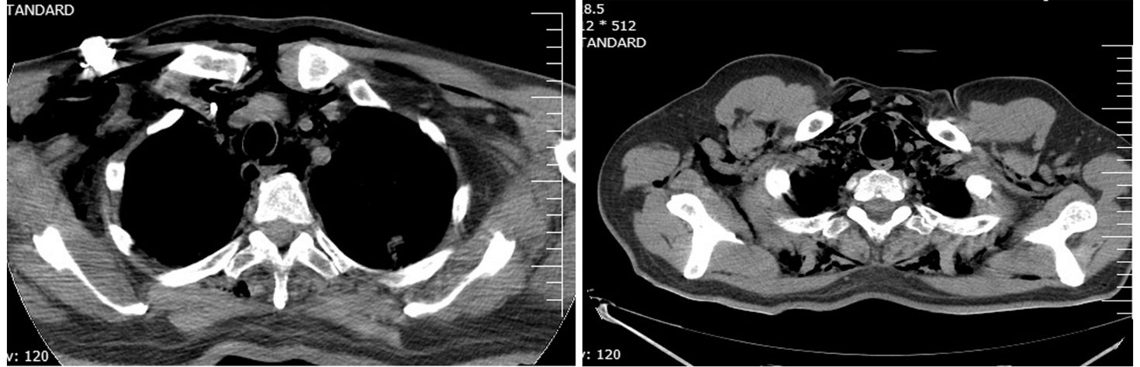

Figure 6. CT scan show pneumomediastinum and subcutaneous emphysema, pneumothorax

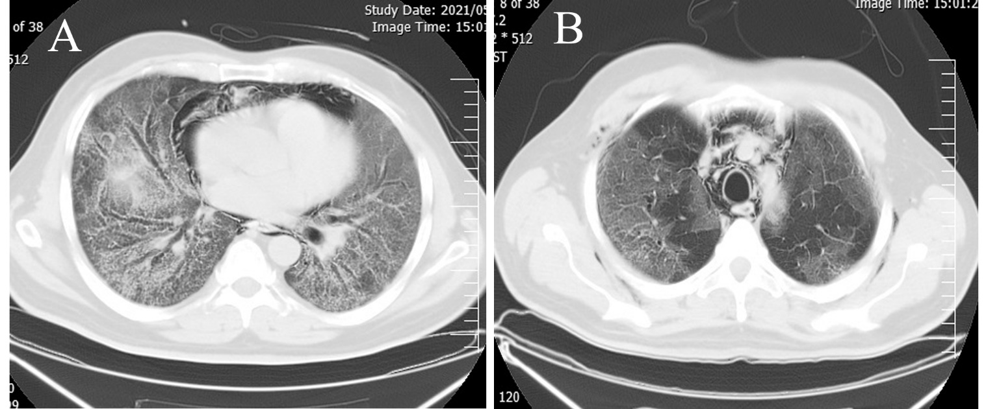

Figure 7. CT scan show pneumomediastinum and subcutaneous emphysema

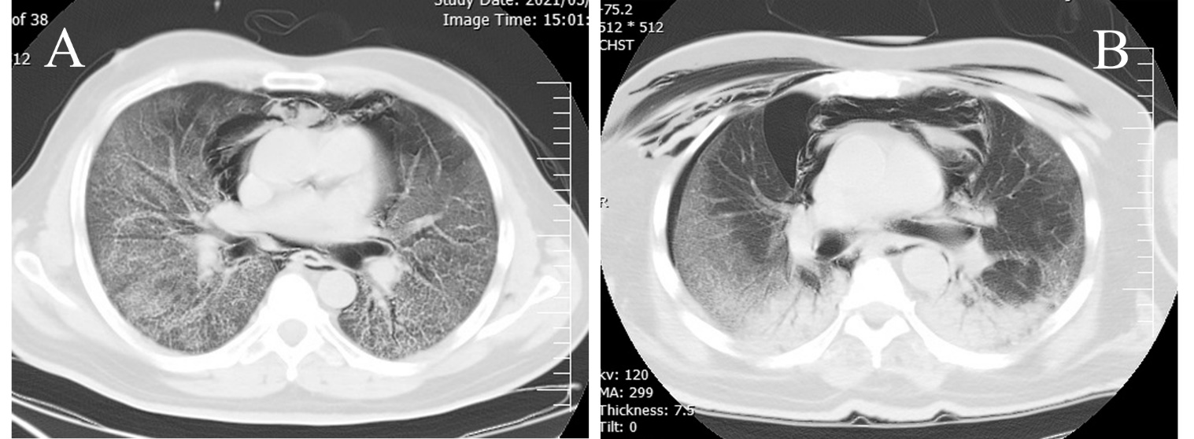

Figure 8. CT scan show pneumomediastinum and subcutaneous emphysema, pneumothorax, pneumomediastinum

