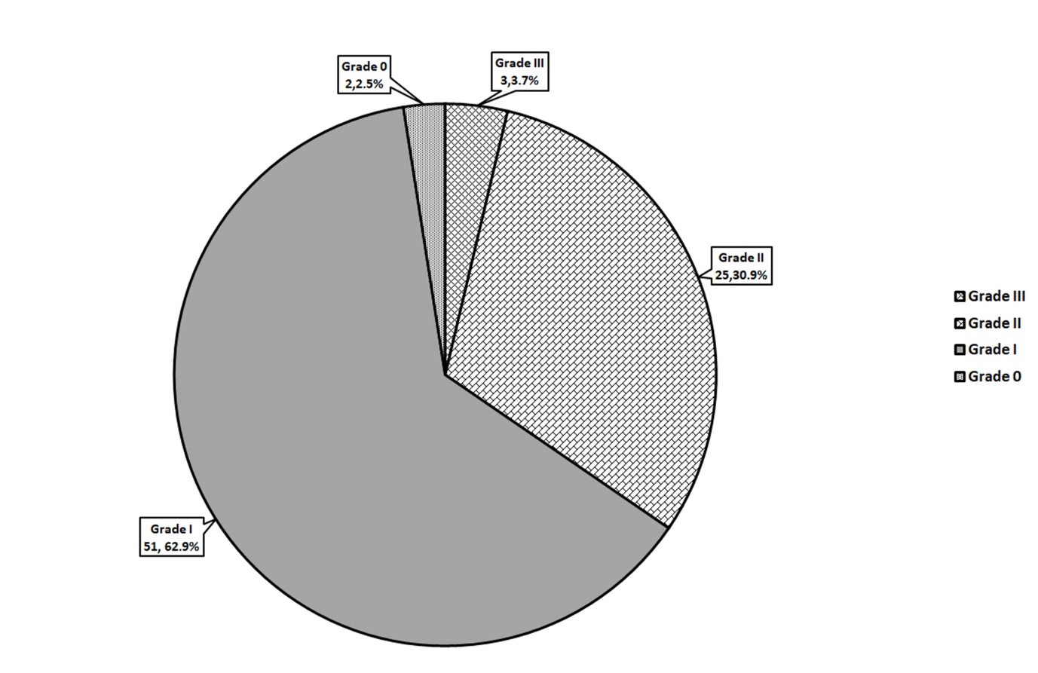

Supplementary Figure 1. The severity of neuropathic symptoms at six month of chemotherapy onset



Supplementary Figure 2. The AP amplitude changes mean of indicated nerves overtime