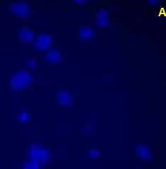
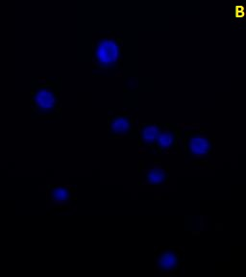
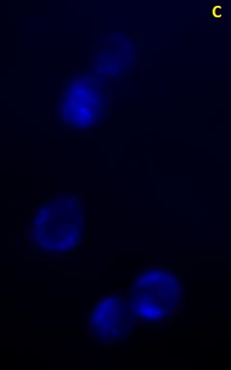

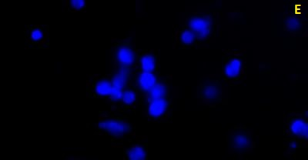
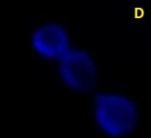

Supplementary Figure 1. Visual macroscopic images of prostate cancer cells stained with the DAPI solution.
A) DMSO treatment, B) Compound C treatment, C) Salinomycin treatment, D) MK-2206 treatment, E) Salinomycin + MK-2206 treatment.

