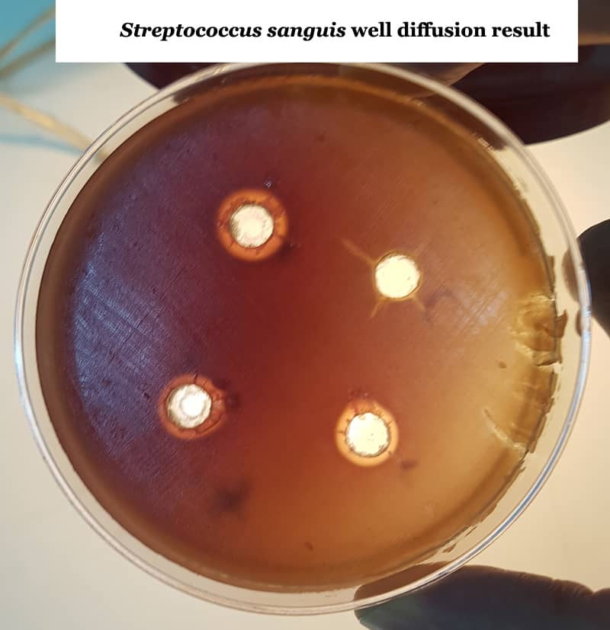
Supplementary figure 1. Disk diffusion method in measuring the inhibition zone of bacteria

