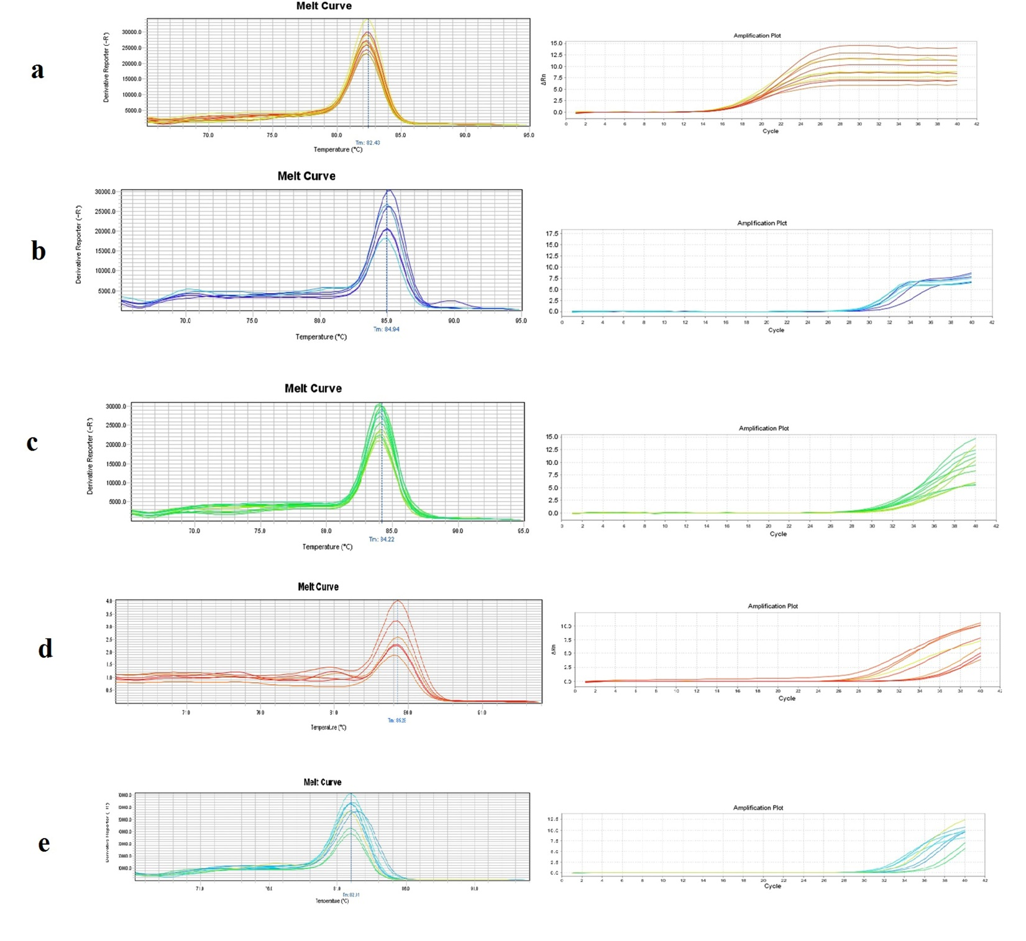
Supplementary file 1. Melt curves and Amplification plots for the reference (ActB) and targeted amplicons of the studied genes. a: ActB, b: ADIPOQ, c: Leptin, d:GLUT4 and e: Akt1.

